Report
Student name and ID:
- Nguyễn Phương An - ITDSIU25001
- Phạm Lê Ngọc Khánh - ITDSIU25014
Lab 6
Problem 1:
- User and Resource are abstract classes because they are general concept. They are used to provide common properties and behaviors for subclasses classes.
- StudentUser, StaffUser, Room and Equipment are subclasses because they inherit common properties and behaviors from the parent class, and they also have their own specific attributes.
- Class User should contains userId, name and email. Because both studen and staff need these information. Similarly, class Resource should contains resourceId, resourceName and isAvailable, because these are the attributes that Room and Equipment need.
UML diagram:
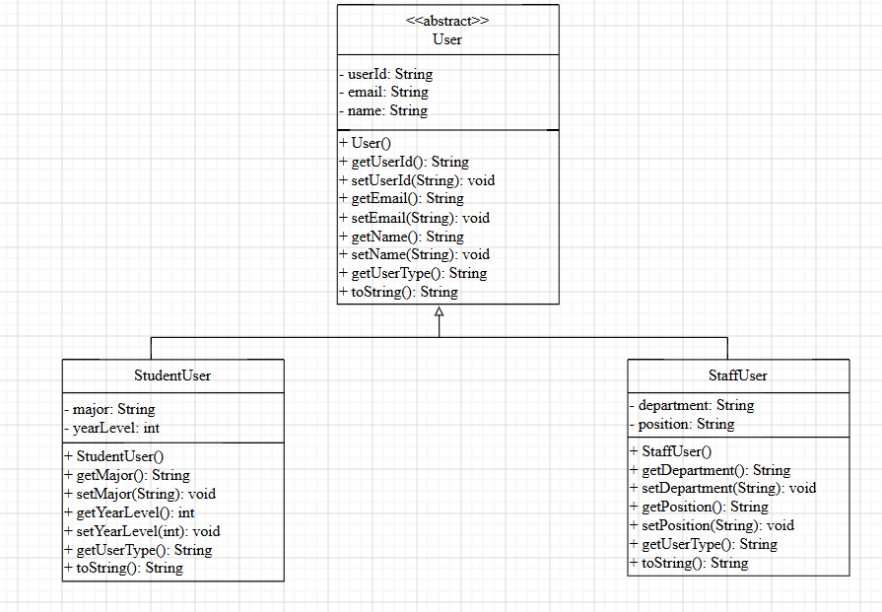
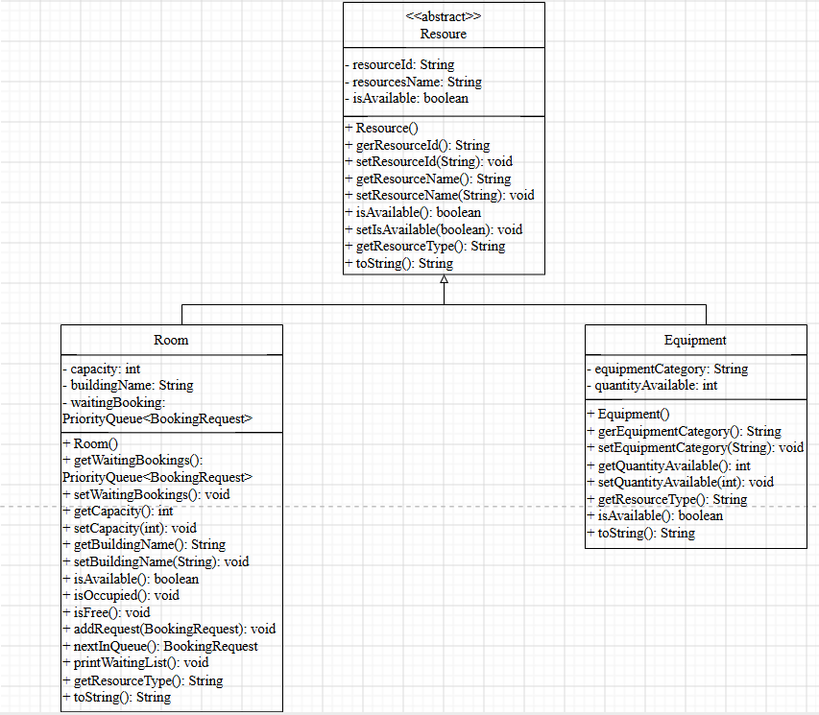
Problem 2:
- BookingStatus and LoanStatus are useful as enum because they restrict the status to fixed set of valid values, prventing invalid inputs and improving type safety.
- Invalid date/time conditions are critical logic errors, so the program should not continue execution and must immediately throw an exception to indicate the problem.
- BookingRequest and LoanRequest are different from User and Resource because User represents people who use the system, Resource represents assets such as rooms or euipment. In contrast, BookingReques and LoaRecord represent transactions or actions between users and resources.
UML diagram:
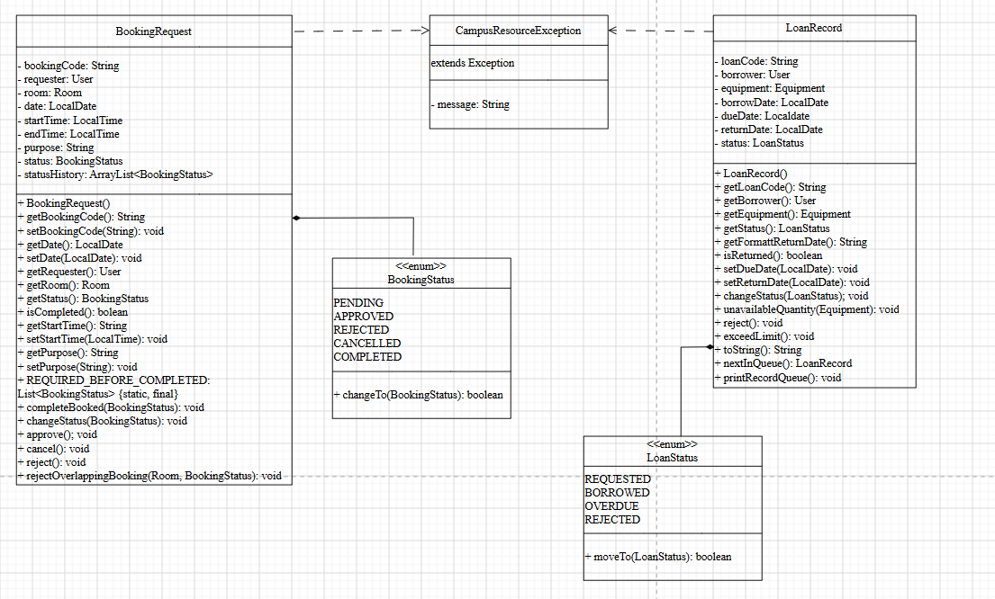
Problem 3:
- State changes should be controlled by methods because methods can validate conditions before allowing a status transition, ensuring that invalid state changes are prevented. This also prevent outside code modifying internal data.
- Allowing outside code change status freely is dangerous because it can break the system rule, leading to invalid or inconsistent. Such as overlapping bookings or incorrect loan statuses. It also makes debugging more difficult since state changes can happen anywhere in the system, making errors harder to fix.
- Rule checking is part of object - oriented design because OOP follows encapsulation, where data and behavior should stay together. The object should contain not only data but also the logic to validate and protect that data, preventing outside code interfere the system.
Problem 4:
- ArrayList<User> is useful because it stores multiple objects of subclasses StudentUser and StaffUser in a single collection through polymorphism.
- HashMap<String, BookingRequest> is useful because each booking has a unique booking code and HashMap allows fast access by using that code as the key.
- CampusResourceSystem contains the objects of the ArrayList<User> and ArrayList<Resource> and manage them. So it is a composition-based class.
- Collections are useful in this type of application because the number of users, resources and bookings in constantly changing. So coolections help sotring multiple objects, flexible addition and deletion, searching and managing data easier.
UML diagram:
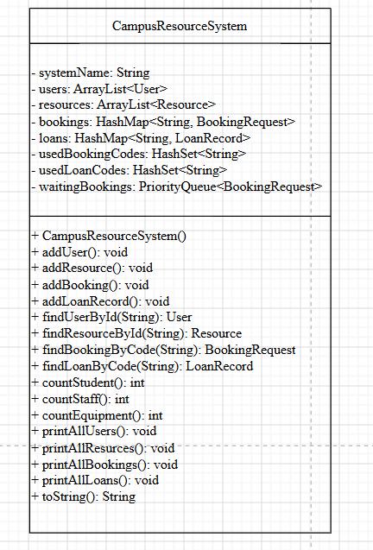
Problem 5:
- Searching is useful because the system contains a lot of data. So search makes it faster, more accurate and easier to manage.
- A list is useful because search result contain multiple items. So use ArrayList to store multiple results, easy to browse by using a loop.
- A map is useful because each object has only one ID. So HashMap help search quickly by using a key, do not need to scroll through the entire list.
- CampusResourceSystem should be responsible for each report, because it manage all data.
Problem 6:
- StudentUser and StaffUser extends User, StudyRoom and Equipment extends Resource.
- Abstraction is used in User and Resource classes.
- ArratList<User> users, ArrayList<Resource> resources, HashMap<String, BookingRequest> bookings, HashMap<String, LoanRecord> loans, Queue<BookingRequest> waitingList and HashSet<String> usedCodes are using collections.
- Composition is used in CampusResourceSystem, BookingRequest and LoanRecord classes. CampusResourceSystem contains users, resources, bookings, loans, waiting list. BookingRequest and LoanRecord both contains User and Resource.
- Exception handling is used for duplicate booking code, duplicate loan cod, borrowing equipment when quantity is 0, creating a new loan when the user already has an overdue loan, invalid date or time input, booking beyond room capacity
- This lab is more difficult because it combines multiple OOP concepts into one system.
UML diagram:
